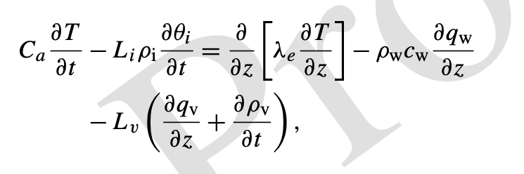

The screenshot above is the equation as it is now presented. The second term on the right-hand side represents the divergence of heat advection. It is a function of temperature, and, by omitting this, we made an error when writing it originally. See eq. (40) in the model documentation: https://www.ars.usda.gov/ARSUserFiles/20520000/shawdocumentation.pdf. There are some slight differences in our nomenclature (we use lambda rather than kappa for thermal conductivity and the subscript w rather than l for liquid water). But, when comparing the equations, clearly there should be a T in the heat advection term. That is the only change. I have rewritten it correctly below. The T should not be bold, I have just made it bold to indicate the change. Also, I changed one set of brackets to parentheses, but that’s up to you.

$$C_{a}\frac{∂T}{∂t}-L_{i}ρ_{i}\frac{∂θ_{i}}{∂t}=\frac{∂}{∂z}\left(λ_{e}\frac{∂T}{∂z}\right)-ρ_{w}c_{w}\frac{∂q_{w}T }{∂z}-L_{v}\left(\frac{∂q_{v}}{∂z}+\frac{∂ρ_{v}}{∂t}\right)$$

