REVISION | ADDRESSING COMMENT | REVIEWER
Lines 13-16 of page 11947, rephrase the sentence 'Whilst........................, 2005).' to become 'whilst the warming and changes in all components of the climate system are hypothetically ascribed to the continued increase in greenhouse gas emissions (Intergovernmental Panel on Climate Change, IPCC, 2013), annual rainfall variability may be attributed to large scale ocean-atmosphere interactions (Fowler and Archer, 2005).'  Lines 13-16 of page 11967, replace the reference 'IPPC: ............., 2001' with  'IPCC: Climate Change 2013: The physical science basis. Contribution of working group I to the fifth assessment report of the Intergovernmental Panel on Climate Change; Cambridge University Press: Cambridge, United Kingdom and New York, USA, 1535pp, 2013.' | Page 11947, line 15: comparison with the latest IPCC report should be mentioned | 3
Line 16 of page 11947, after 'Whilst..................(Fowler and Archer, 2005)', insert the sentence 'Rainfall variability can also be influenced by regional features such as water bodies, topography, transition in land cover and/or use etc.'  Line 13 of page 11948, insert a comma ',' after 'instructions' and delete 'and/or'  Line 13 of page 11948, insert, after 'factors' the phrase 'as well as the influence from regional features such as water bodies, topography etc.'  Line 14 of page 11949, after 'Inter-annual variability...................practices.', insert the sentence 'It is important to note that for brevity in this paper, only the rainfall variability driving forces from the large-scale ocean-atmosphere interactions (but not the influence from anthropogenic factors or regional features) were considered.' | Page 11964, lines 26-28: this sentence is very important and should have been included in some way also in the introduction in order to better clarify the limits of this study, besides as far as topography is concerned. | 3
Lines 8-9 of page 11948, replace 'very frenzied' with 'widespread'  Line 9 of page 11948, replace 'high' with 'frenzied' | Page 11948, line 8 : can 'poverty' be really 'frenzied'? I thought 'population growth' could be frenzied, not poverty... | 3
Line 9 of page 11949, after 'Outside the study area.............the Andes region of Ecuador.' insert a new paragraph with the below text.  The shortcomings of the above recent studies that applied the QPM on the rainfall variability of the Nile Basin as addressed in this study include:  1) lack of attempts to investigate any possible linkages of the rainfall variability to ocean-atmosphere interactions by Mbungu et al. (2012), and Onyutha and Willems (2014a, b), (2) the use of few climate indices or series to explain rainfall variability by Moges et al. (2014), Nyeko-Ogiramoi et al. (2013), and Taye and Willems (2012), and (3) the limitation of the variability study to sub catchments of the Nile Basin. In line with shortcoming (3), considering the entire River Nile Basin would be helpful in understanding the regional differences in the rainfall statistics. This is vital in regional planning for the management of agricultural practices given that subsistence and rain-fed agriculture, together with high rainfall variability is one of the main causes of food insecurity and the most daunting challenge the entire Nile Basin faces (Melesse et al. (2011).  Page 11968, Between 'McHugh............' and 'Moges...........' insert the new reference ' Melesse, A. M., Bekele, S., and McCornick, P.: Introduction: hydrology of the Nile in the face of climate and land-use dynamics. In: Nile River basin: hydrology, climate and water use, edited by: Melesse, A.M., Dordecht, The Netherlands: Springer, vii–xvii, 2011.' | The authors should explain in details the innovating aspects of this study compared to previous publications. | 2
Line 22 of page 11949 after ‘…………data points not more than 10% were used’, insert new sentences 'However, to check on the spatial coherence of the variability results across the study area, the period of not less than 35 years over which each station had rainfall data was considered. This was done because of the spatial coherence of the temporal variability results that could be obtained on a regional basis when data from the different meteorological stations are of the same length and picked over the same time period for analysis.' | Lines 7-8 p. 11959: “Correlations for groups A to C are obtained over the periods in which each station had data records i.e. 1935–1970 (36 years?), 1954–1992 (39 years?) and 1945–1985 respectively.” This is apparently in contrast with lines 20-22 at p. 11949: “To enhance the acceptability of the research findings, long-term rainfall series of length not less than 40years and missing data points not more than 10% were used.” and Table 1. Please check. | 2
Line 3 of page 11951, insert 'stronger' in between 'its' and 'variability' | Page 11951, line 3: 'runoff values and its variability' should rather be 'runoff values and its stronger  variability' | 3
Line 12 of page 11954, after the sentence '.........entire time series.', insert a new paragraph with the text below:  It is well-known that the estimation of Ts from small sample series can be characterized by bias. This bias becomes large when the T being estimated (by extrapolation after fitting theoretical distribution in the frequency analysis) is far higher than the data record length. To ensure that the bias in the anomalies computed over each time slice does not significantly affect the QPM variability results, extrapolations are avoided. This is done by considering only the empirical Ts i.e. Ts not greater than D (for each time slice) or n (for the full series). | With reference to the methodology, the QPM is based on a comparison between quantiles with similar return periods derived from the complete time series of length n and subseries of fixed length D. Return periods are computed as n/j or D/j, with j the rank of each value of the series sorted in descending order. For small sample series (i.e. n<100) the latter represents a biased estimator of return periods for all distributions, thus in principle it would not be recommended. The authors should demonstrate that the use of an unbiased estimator does not change the results significantly. | 2
Line 15 of page 11954, insert '(Figure 2a)' after '15 years'.  Line 16 of page 11954, insert these two sentences in between "....the study." and "A block length........" 'It can be noted from Fig. 2a that the computed anomalies are over/underestimated for lower than higher time slice. Furthermore, as the block length increases, the pattern of persistence in the rainfall quantiles becomes smoother or clearer.' | Page 11954, line 16-18: evidence to this finding should be included or the finding itself should be  better explained: in what sense the given oscillation pattern was given clearer? | 3
Replace the old Figure 2 on page 11978 with the new one attached (also shown at the end of this table). | Page 11956, line 3: the up and down arrows are missing in figure 2 | 3
 | Page 12-Line 3. It is  written in the text “The up and down arrows: : :.”. However, there are no arrows in figure. | 1
Page 11978, change the caption of Figure 2 to 'QPM results at station 7 for the period 1935–1970 using time slice(s) a) considered in sensitivity analysis (5, 10 and 15 years), and b) selected for the study (15 years).' | 2) Figure 2. The name of the station (i.e. station 7) should be mentioned in the caption of the figure. | 1
Line 11 of page 11958, replace 'Kiiza' by 'Kizza' | Page 11958, line 11: is it Kiiza or Kizza (as listed in the reference list)? | 3
Line 15 of page 11958, change '1930s' to '1920s'  Line 17-18 of page 11958, delete the sentence 'Another period of OH was in the early 1920s to mid 1930s. This OH was significant at stations 18, 21–23, and 27.' | Page 11958, lines 15-18: a whole OH is actually split in two separate OH for the analysis, this  should be explained and motivated. | 3
Lines 1, 8 and 17 of pages 11959, 11963, and 11963 respectively, insert 'rainfall' between 'MAM' and 'of'  Line 1 of page 11959, insert 'rainfall' between 'JJAS' and 'of' | Page 11963, line 17: 'MAM of group A' should rather be 'MAM rainfall of group A' | 3
Line 21-23 of page 11960, rephrase this sentence to become: 'The spatial maps for correlations between HadSLP2 or HadSST2 and annual rainfall are presented in Figs. 5 and 6. For the correlations between HadSLP2 or HadSST2 and the rainfall in the main wet seasons of the different groups, the spatial maps are shown in Figs. A1 and B1.' | Lines 21-23 p. 11960. “Although for brevity, spatial maps for correlations between HadSLP2 or HadSST2 and annual rainfall are presented Figs. 5 and 6, for those with the rainfall in the main wet seasons of the different groups, see Figs. A1 and B1.” Please rephrase. | 2
Grist, J. P. .........(in lines 20-21 of 11966),  Goovaerts, P. .........(in lines 23-23 of 11966), and Gleick, P. H. .....(in lines 24-27 of 11966), should be rearranged alphabetically in the order:  Gleick, P. H. ..........  Goovaerts, P. .........  Grist, J. P. ............  The reference Kundzewicz.....(in lines 30-31 of page 11967) and Kummu......(in lines 1-3 of page 11968) should be arranged alphabetically in the order:  Kummu..................  Kundzewicz.................... | Pages 11966-11967: in these two pages the references are not always listed in alphabetical order  (Grist, Goovaerts, Gleick, … and then Kundzewicz, Kummu) | 3
Line 15 of page 11969, change 'Gaddi-Ngirare, K.' to 'Ngirane-Katashaya, G.' | Correction based on observation from the authors
Page 11975, change the caption of Table 4 to 'Correlation between QPM results for annual rainfall and climate indices over the periods1935–1970 (for group A), 1954–1992 (for group B) and 1945–1985 (for group C).'  Page 11976, change the caption of Table 5 to  'Correlation between QPM results for annual rainfall and climate indices considering full series with lengths of data records shown in Table 1.'  Page 11981, change the caption of Figure 5 to  'Correlation between anomaly in annual Sea Level Pressure (SLP) and that in region-wide annual rainfall for group (a) A, (b) B, (c) C. In the legend, Gp denotes group.'  Page 11982, change the caption of Figure 6 to  'Correlation between annual Sea Surface Temperature (SST) and that in region-wide annual rainfall for group (a) A, (b) B, (c) C. In the legend, Gp denotes group.' | I suggest to homogenize captions of Tables 4 and 5, as well as captions of Figures 5 and 6. | 2
Replace the old Figure 1 on page 11977 with the new one attached (also shown at the end of this table). | Figure 1: I would use different symbols for the three different station groups and I would add country boundaries. LTM is not obvious, Long Term Mean should be written in the caption. | 3
 | Figure 1. The groups of rainfall stations (i.e. A, B, C) should be shown in Figure 1. | 1
Replace the old Figure 7 on page 11983 with the new one attached (also shown at the end of this table).  Second line of the Figure 7 caption on page 11983, Change ‘( )’ to ‘[ ]. | Figure 7: In the caption only charts a-c and d-f are explained, what are g-h?? | 3
Page 11986, in the caption of Figure B1, change 'SLP' to 'SST' | Figure B1: in the caption SLP should be substituted by SST. | 3

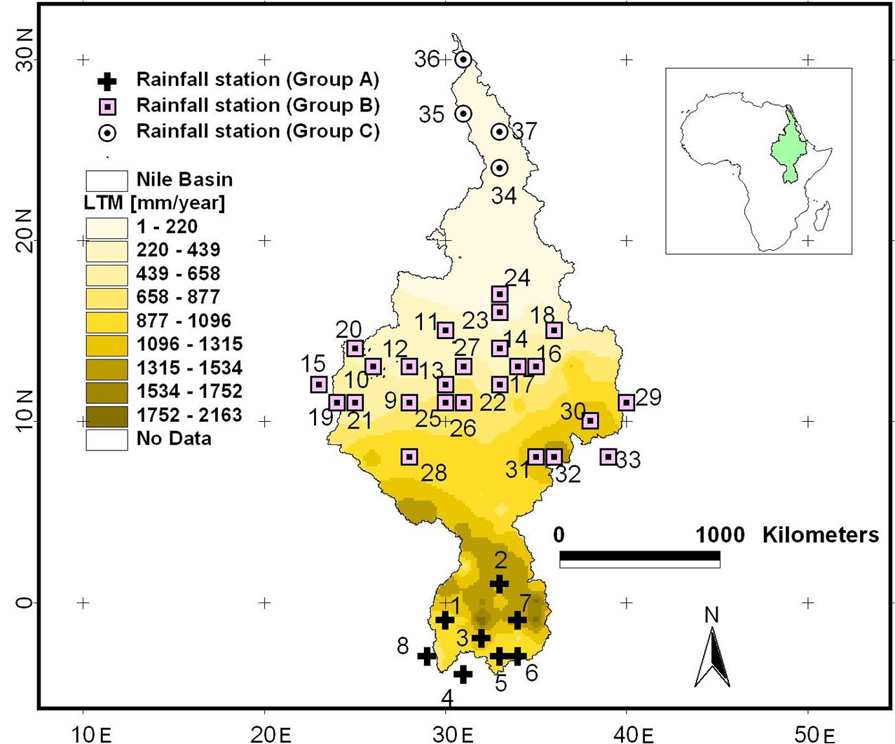
Figure 1. Locations of the selected meteorological stations (see Table 1 for details) in the Nile Basin; the background is based on the Long Term Mean (LTM) of annual rainfall.
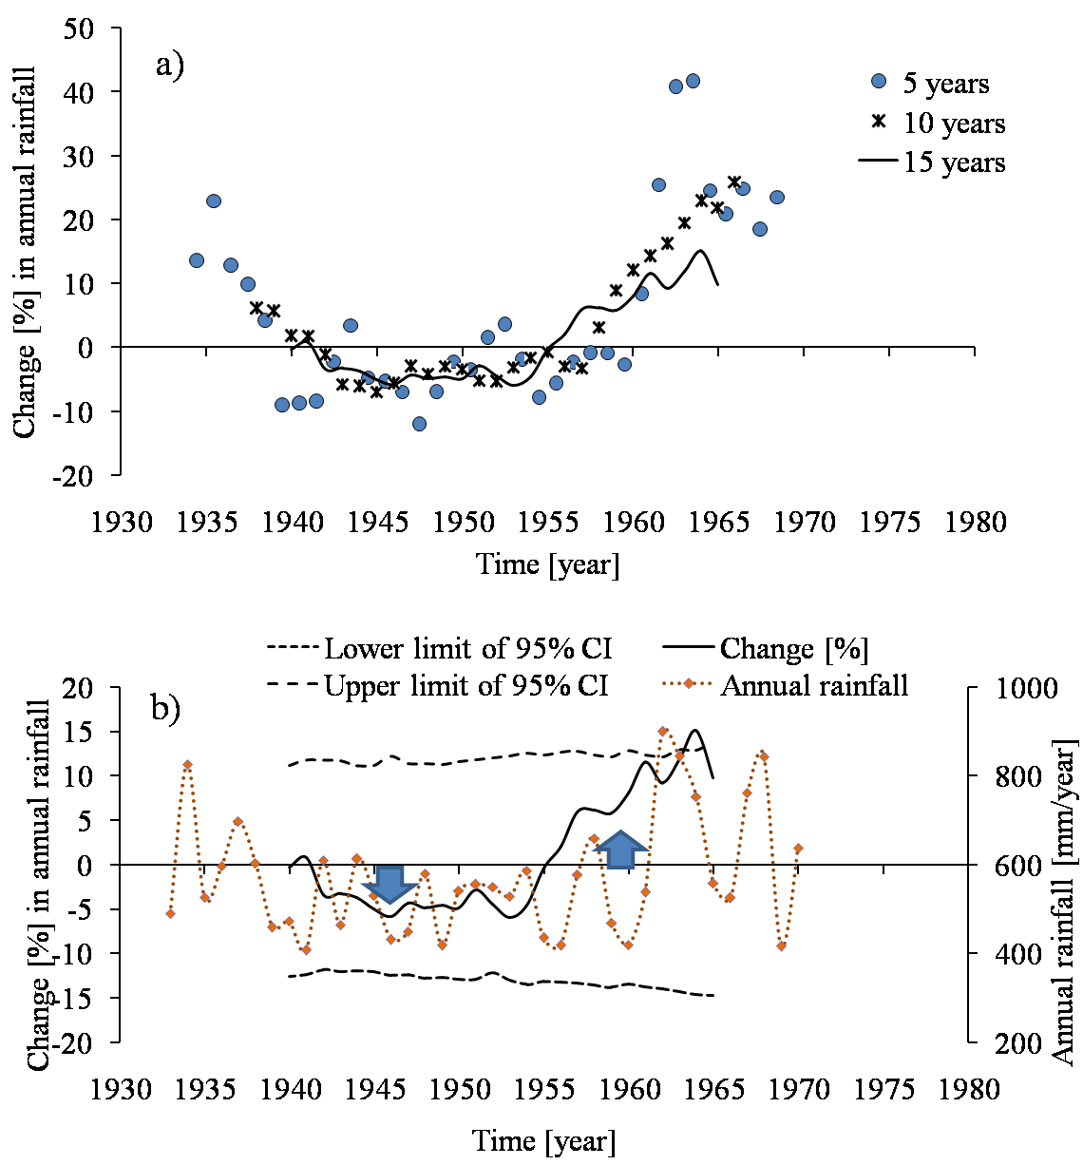
Figure 2. QPM results at station 7 for the period 1935–1970 using time slice(s) a) considered in sensitivity analysis (5, 10 and 15 years), and b) selected for the study (15 years).

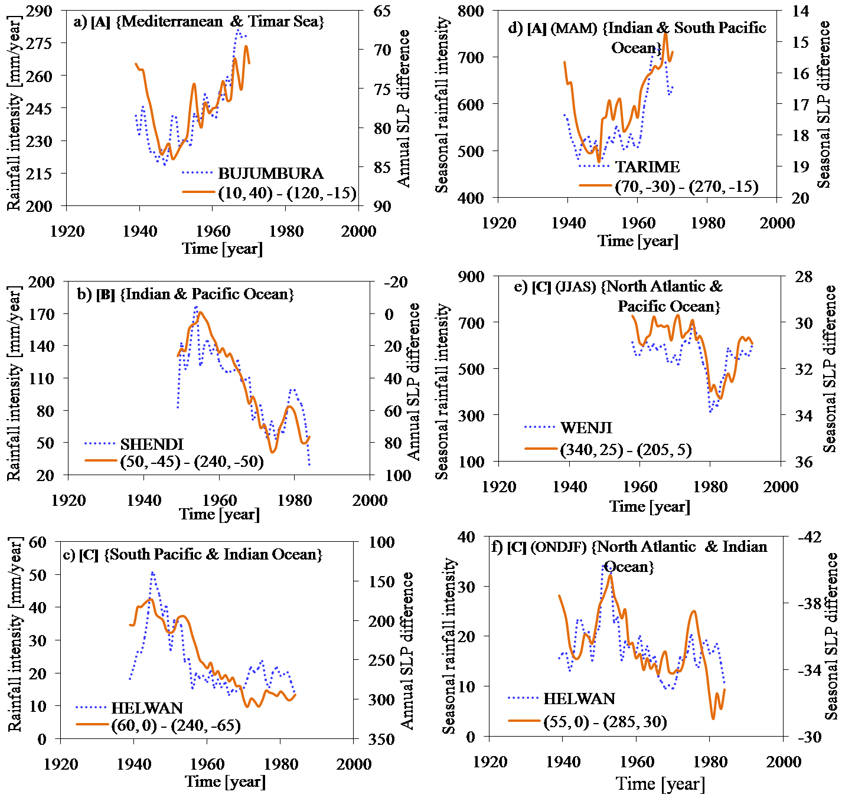
Figure 7. Annual SLP differences and rainfall at selected stations of the different groups A–
C for a time slice of 5 years; the group labels are in [ ]. The label of a legend indicates the
coordinates (degree longitude and latitude) from where the SLP differences were taken. The
label in { } show the locations where the coordinates are found. Annual and seasonal time
scales are shown in charts (a)–(c) and (d)–(f) respectively.

